Virtual Gaming



**B.S. (CS) Final year Project Report**

**Submitted by:**

**Anbreen Jahan 2015/COMP/BSCS/18572 1518442**

**Juwairiah Saleem 2015/COMP/BSCS/18591 1518459**

**Mahwish Naseem 2015/COMP/BSCS/18595 1518464**

**Naveera Jamil 2015 /COMP/BSCS/18599 1518468**

**Project Advisor:**

**Miss Ummay Fasiha**

**Miss Anisa Ahmed**

**July 2018**

**Department of Computer Science and Information Technology**

##### Jinnah University for Women

5-C Nazimabad, Karachi 74600

**ABSTRACT**

Brain-computer interface (BCI) is a progressing area that has been adding this whole new dimension of capability to HCI. BCI has created a unique communication channel, mainly for the ones who're incapable to generate the required muscular movements in their daily life to control the common devices. The patients who suffer from Thalassemia or dialysis undergo painful treatments with time duration of 2-3 hours which is quite long. The engagement of their hands due to the canola drips makes them even more mentally disturbed. They are unable to carry out any task utilizing hands and feet except from watching the screens which can be very exhausting after some time. They need some enjoyable entertainment especially during their treatment to divert their mind from the pain they endure. Furthermore, Studies shows that the ADHD (Attention deficit hyperactivity disorder) patients are also treated by the neuro-feedback, since they tend to lose the focus easily very often. Taking these issues in consideration, we proposed a solution called Virtual Gaming, which comprises of an EEG (electroencephalogram) headset. EEG safely measures brainwave signals and monitors the concentration and attention levels of users as they interact with the system in order to play the game. The proposed solution aims to provide those patients an ease and means of entertainment during the treatment without any involvement of the hands. Also, the proposed system acts as a mind booster for normal people to increase attention, focus and concentration.

# **Table Of Content**

Contents

**ABSTRACT** 2

**Table Of Content** 3

**List Of Figure** 3

**ACKNOWLEDGEMENT** 3

**CHAPTER 1** 4

**SOFTWARE REQUIREMENT SPECIFICATION** 4

**1.1** **Purpose** 5

**1.2** **Product Scope** 5

**1.2.1** **For Kidney or Thalassemia Patients** 5

**1.2.2** **For Paralyze Patients** 5

**1.2.3** **New Experience to Gamers** 5

**1.3** **Overall Description** 6

**1.3.1** **Product Perspective** 6

**1.3.2** **Product Function** 6

**1.3.3** **User Characteristic** 6

**1.3.5** **Design and Implementation Constraints** 6

**1.3.6** **User Documentation** 6

**1.3.7** **Assumption and Dependencies** 7

**1.4** **System Features** 7

**1.5** **Other Non-Functional Requirement** 7

**1.5.1** **Performance Requirement** 7

**1.5.2** **Safety Requirements** 7

**CHAPTER 2** 7

**ANALYSIS AND DESIGN** 8

**2.1** **Work Flow Diagram** 8

**2.2** **Relational Model** 8

**2.3** **Use Case Diagram** 9

**2.4** **Activity Diagram** 9

**2.5** **Deployment Diagram** 10

**2.6** **Other Diagram** 10

**2.6.1** **ER Diagram** 10

**CHAPTER 3** 11

**TOOLS AND TECHNOLOGY** 11

**3.1** **Software** 11

**3.1.1** **Arduino IDE** 11

**3.1.2** **3D Max** 11

**3.1.3** **Photoshop CS6** 11

**3.1.4** **Tera term** 11

**3.1.5** **Unity 3D** 12

**3.2** **Hardware** 12

**3.2.1** **Mind Flex EEG Headset** 12

**3.2.2** **Arduino Leonardo** 12

**CHAPTER 4** 13

**USER INTERFACE DESIGN** 13

**4.1** **Web User Interface** 13

**4.1.1** **Contact Form** 13

**4.2** **Hardware Interface** 13

**4.2.1** **EEG Headset connection with Bluetooth Module** 13

**4.3** **Game User Interface** 14

**4.3.1** **Splash Screen** 14

**4.3.2** **Main Screen** 14

**4.3.3** **Car Selection** 15

**4.3.4** **Level Selection** 16

**4.3.5** **Game Over** 16

**IMPLEMENTATION** 17

**5.1** **Website Design** 17

**5.1.1** **Home** 17

**5.1.2** **Features** 18

**5.1.3** **Project Components & Team** 19

**5.1.4** **Contact** 20

**CONCLUSION** 21

**A.** **Glossary** 22

# **List Of Figure**

Figure 2.1: Work flow Diagram 10

Figure 2.2: Relational Model 10

Figure 2.3: Use Case Diagram 11

Figure 2.4: Activity Diagram 11

Figure 2.5: Deployment Diagram 12

Figure 2.6: Entity Relationship Diagram 12

Figure 7:Contact Form 15

Figure 8:Splash Screen 16

Figure 9:Main Screen 16

Figure 10:Car Selection Buggy 17

Figure 11:Car Selection Sedan 17

Figure 12:Level Selection 18

Figure 13:Game Over 18

Figure 14:Home 19

Figure 15:Features 20

Figure 16:Project Components & team 21

Figure 17:Contact 22

# **ACKNOWLEDGEMENT**

First of all, we thank to Almighty Allah who gives us the strength and ability to think, work and deliver what we are assigned to do. Secondly, we must be grateful to our course in charge Miss Fasiha and Miss Anisa who guided us in this project. We also acknowledge our teachers who guided, taught and helped us during our whole study period.

# **CHAPTER 1**

# **SOFTWARE REQUIREMENT SPECIFICATION**

## **Purpose**

Virtual gaming allows user to play any game only with the power of their mind. It is like a game controlled by the mind. The user doesn't need to press any key, just think, focus and play. Brainwaves will be interpreted with EEG Headset over Bluetooth connection and the game will run according to the user’s thoughts. Virtual Gaming gives ability to those people who are struggling each day with their disabilities. It is also like an exercise for the mind because the headset requires great focus and concentration which can help increase mental focus of those who are tend to lose it e.g. ADHD patients. We will also develop a game to motivate the people with any disabilities or diseases to help them fight with it. This project would not only facilitate below neck paralyzed patients but also enable the normal-bodied people to control game telepathically without lifting a finger.

## **Product Scope**

### **For Kidney or Thalassemia Patients**

This project is very beneficial for kids who are suffering from thalassemia disease or kidney renal failure (dialysis patients) because their treatments are too painful and time consuming**.**

### **For Paralyze Patients**

Virtual Gaming hold great potential for people who are paralyzed or otherwise unable to use their hands.

### **New Experience to Gamers**

Virtual Gaming doesn’t only facilitate patients but also it will be a new experience for the gamers as well.

## **Overall Description**

### **Product Perspective**

The product Virtual Gaming, is specially designed for the children who undergo treatments like Dialysis,Thalassemia and ADHD patients. This product helps children to increase their focus through gaming. Virtual Gaming also facilitates the normal people that gives new experience to gamers.

### **Product Function**

Brainwaves will be interpreted with EEG Headset over Bluetooth connection and the game will run according to the user’s thoughts. It is also like an exercise for the mind because the headset requires great focus and concentration which can help increase mental focus of those who are tend to lose it e.g. ADHD patients

### **User Characteristic**

The target users are those who are physically disable and normal people, because this is beneficial for both category of users.

* + 1. **Operating Environment**

This car game can also operates on pc and mobile.

### **Design and Implementation Constraints**

* A computer with windows or linux operating system.
* EEG Headset should be paired with Bluetooth module.

### **User Documentation**

Along with game it helps to provide the user to pass there time at the time of treatment and also for new experiencefor gamers.

### **Assumption and Dependencies**

* The user should be familiar to car game.
* The user should also know about headset.
* The user should have to concentrate to play the game.

## **System Features**

Virtual gaming is designed with an to provide an entertainment to those who undergo treatments like dialysis or thalassemia and also for those who want a new user experience in playing game.

## **Other Non-Functional Requirement**

### **Performance Requirement**

Our project will be for single player. User’s brainwave information and standard inputs will be handled and affect the game with information interpretation.

### **Safety Requirements**

Before putting on the headset, turn the volume control to its lowest level, put on the headset, and then slowly adjust the volume control to a comfortable level.

# 

# **CHAPTER 2**

# **ANALYSIS AND DESIGN**

## **Work Flow Diagram**

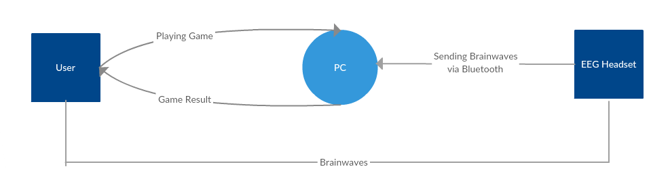

Figure 2.1: Work flow Diagram

## **Relational Model**

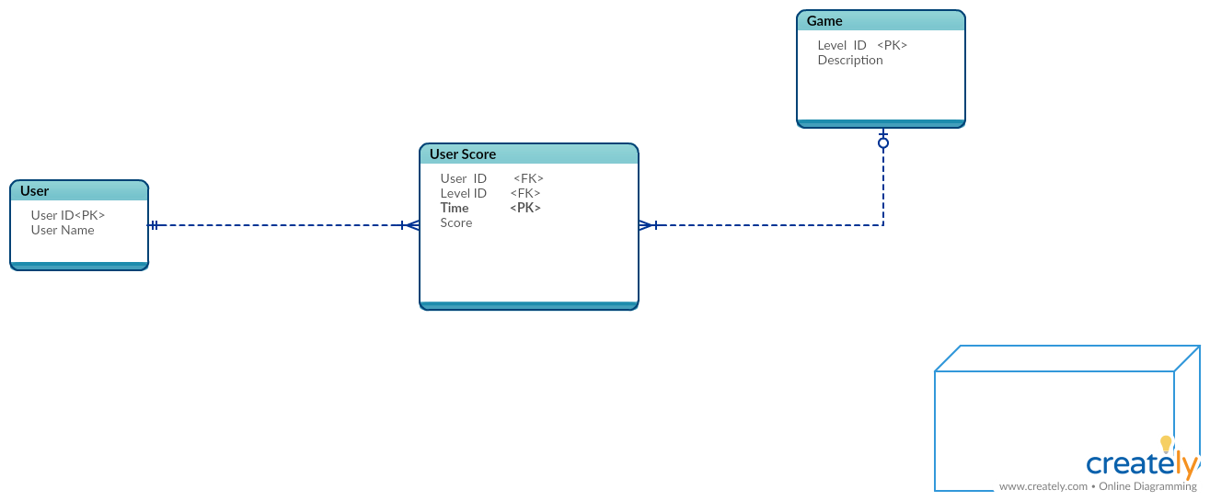

Figure 2.2: Relational Model

## **Use Case Diagram**

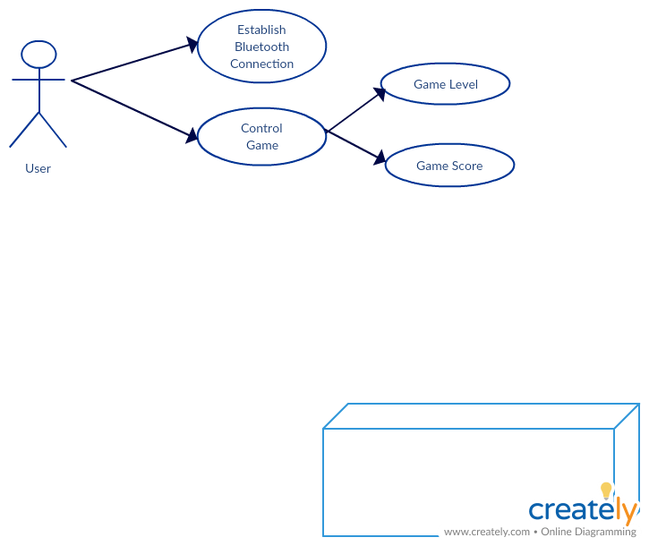

Figure 2.3: Use Case Diagram

## **Activity Diagram**

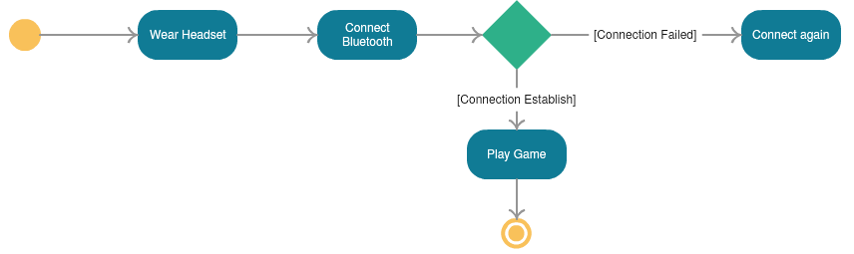

Figure 2.4: Activity Diagram

## **Deployment Diagram**

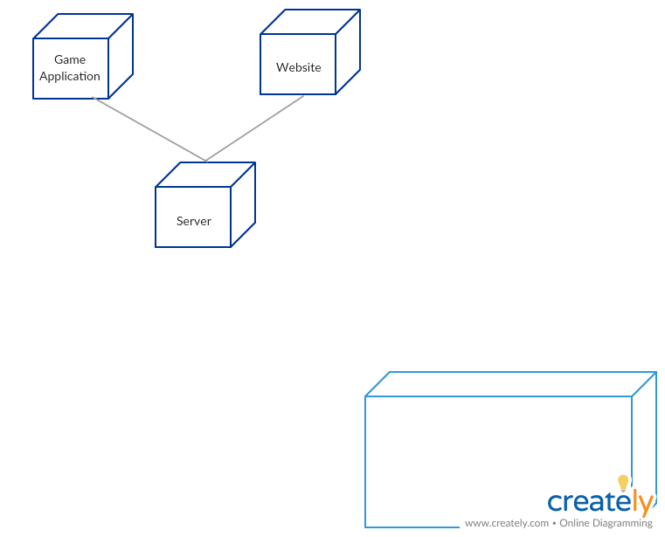

Figure 2.5: Deployment Diagram

## **Other Diagram**

### **ER Diagram**

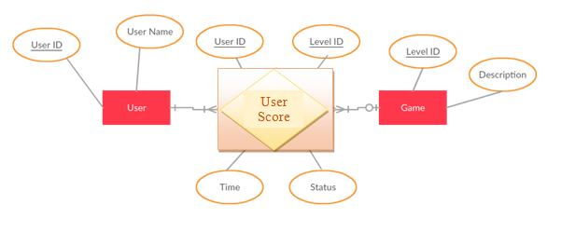

Figure 2.6: Entity Relationship Diagram

# **CHAPTER 3**

# **TOOLS AND TECHNOLOGY**

## **Software**

### **Arduino IDE**

Arduino [integrated development environment](https://en.wikipedia.org/wiki/Integrated_development_environment) (IDE), which is a [cross-platform](https://en.wikipedia.org/wiki/Cross-platform) application written in the programming language [Java](https://en.wikipedia.org/wiki/Java_(programming_language)). It originated from the IDE for the languages [*Processing*](https://en.wikipedia.org/wiki/Processing_(programming_language)) and [*Wiring*](https://en.wikipedia.org/wiki/Wiring_(development_platform)). It includes a code editor with features such as text cutting and pasting, searching and replacing text, automatic indenting, [brace matching](https://en.wikipedia.org/wiki/Brace_matching), and [syntax highlighting](https://en.wikipedia.org/wiki/Syntax_highlighting), and provides simple *one-click* mechanisms to compile and upload programs to an Arduino board.

### **3D Max**

3D Max is a tool for developing different type of model. As we are developing Karachi environment game we used this tool to draw tomb of Quaid-e-Azam and other things through this tool.

### **Photoshop CS6**

Photoshop is unlike other common software interfaces which emulate virtual typewriters or graphing paper. Photoshop creates an artist's virtual studio/darkroom. When you open the program you see a toolbox on the left with tools you will use to manipulate your images, and on the right, a white square which is your "canvas" or work area. The gray area surrounding the canvas is not part of your image, but only defines its edges.

### **Tera term**

Tera Term is a serial software. We use this tool to find out the ip address of EEg Headset and to re-configure Bluetooth HC-05 Module.

### **Unity 3D**

For the development of the game “Mind Racer” we used Unity 3D. Unity is a cross-platform game engine developed by Unity Technologies, which is primarily used to develop both three-dimensional and two-dimensional video games and simulations for computers, consoles, and mobile devices.

## **Hardware**

### **Mind Flex EEG Headset**

The EEG headset is widely available in the consumer market. There are many kinds of headset like EPOC by Emotive, Mind flex and Mind wave by NeuroSky. We use MindFlex EEG Headset in our project.The users have to connect the clips to their earlobesand align the metal forehead sensor just above their left eyebrow.

### **Arduino Leonardo**

The **Arduino Leonardo** is a microcontroller board based on the ATmega32u4. Similar to an Arduino UNO, can be recognized by computer as a mouse or keyboard.

# **CHAPTER 4**

## **USER INTERFACE DESIGN**

## **Web User Interface**

### **Contact Form**

User Contact us through contact form in result of any query .

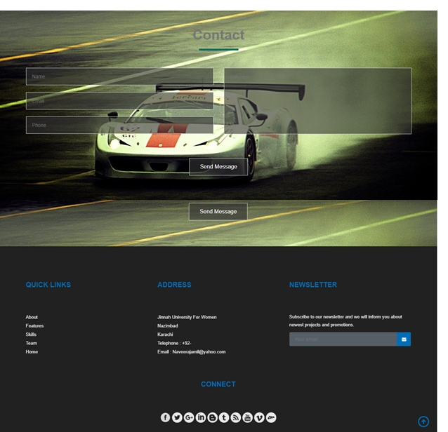

Figure 7:Contact Form

## **Hardware Interface**

### **EEG Headset connection with Bluetooth Module**

User should first connect headset with Bluetooth. After establishing a secure connection can control the game via brain.

## **Game User Interface**

### **Splash Screen**

When user taps on game icon, it first displays the splash screen.



Figure 8:Splash Screen

### **Main Screen**

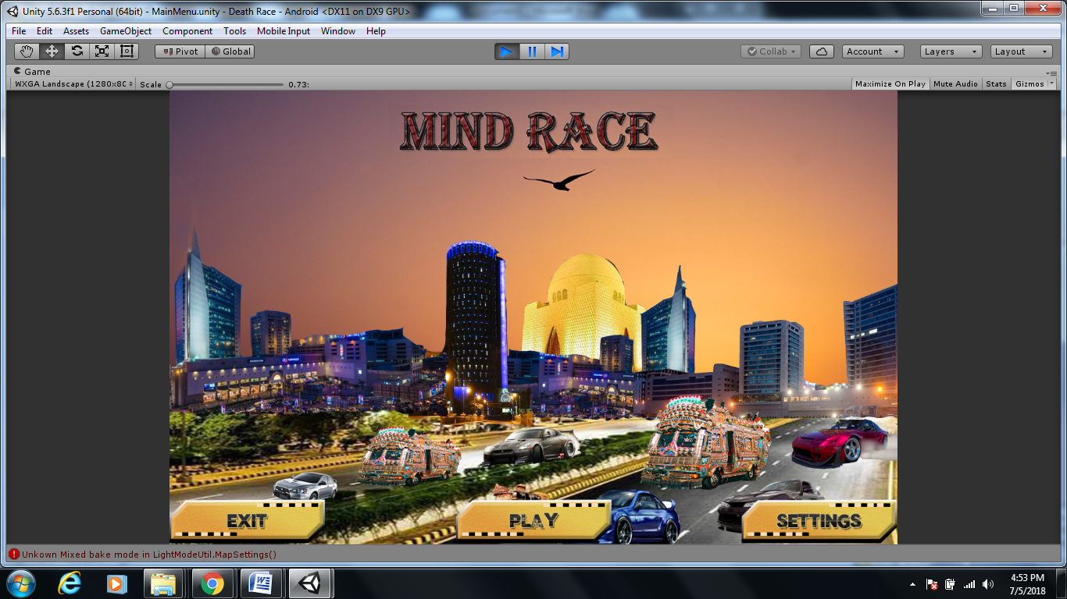

Figure 9:Main Screen

### **Car Selection**

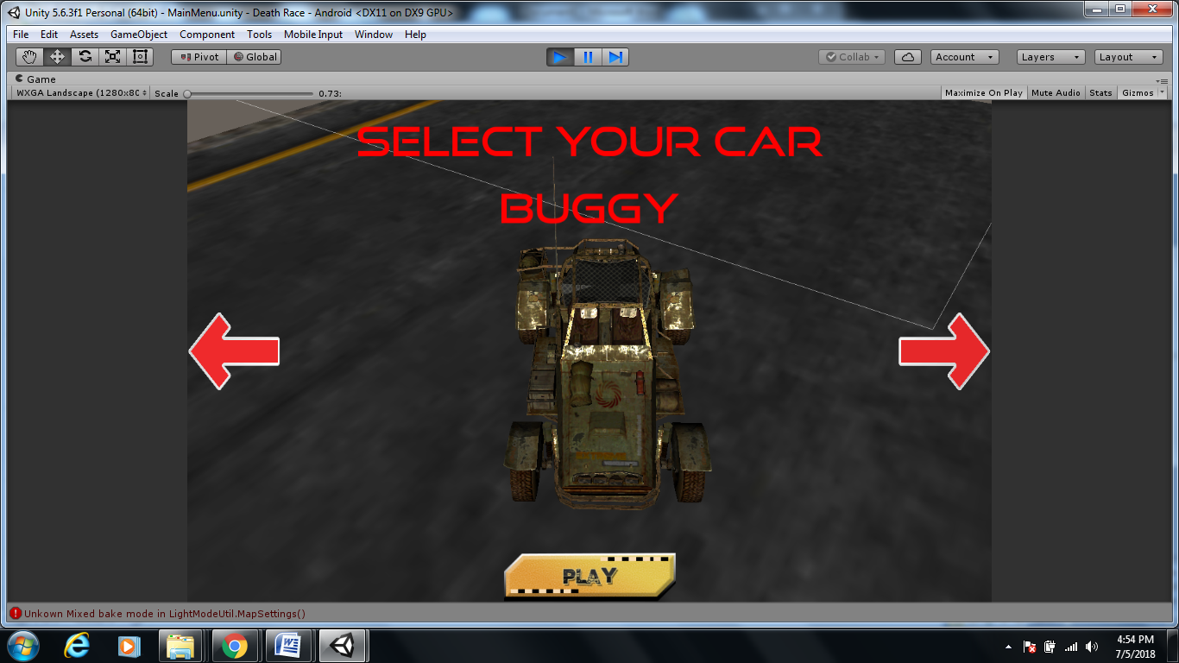

Figure 10:Car Selection Buggy

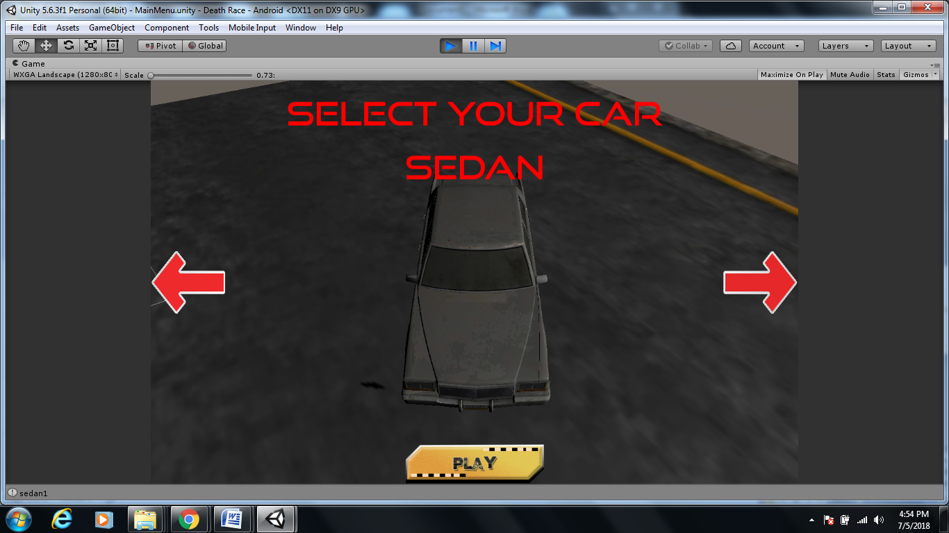

Figure 11:Car Selection Sedan

### **Level Selection**

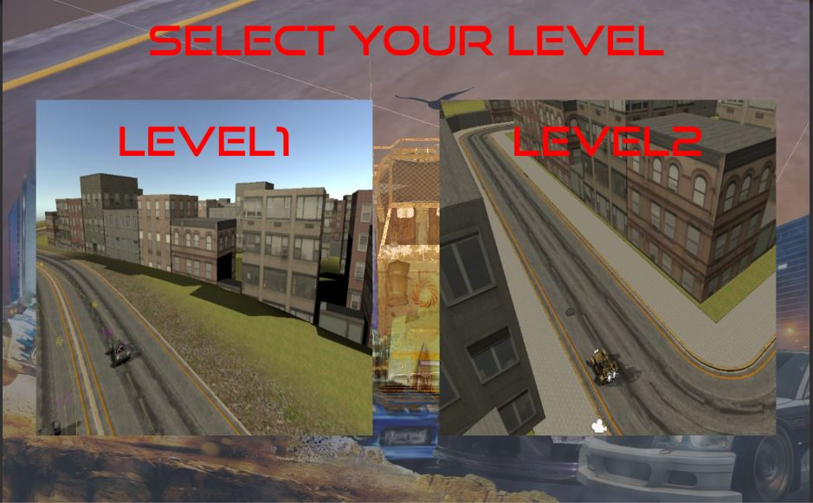

Figure 12:Level Selection

### **Game Over**

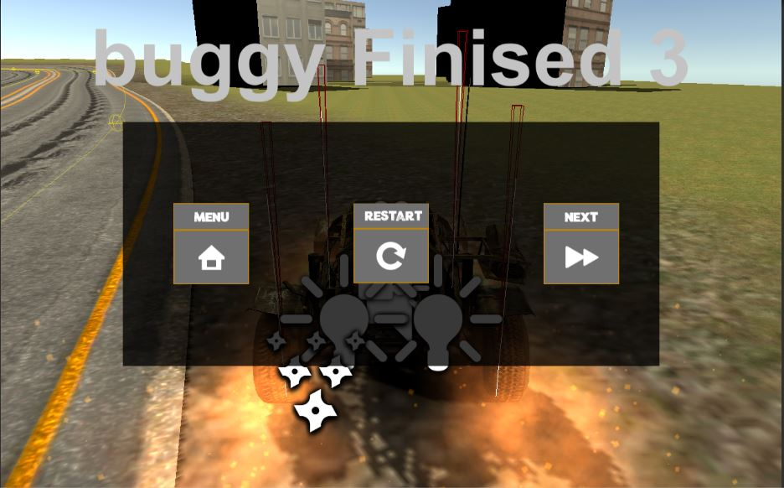

Figure 13:Game Over

CHAPTER 5

# **IMPLEMENTATION**

## **Website Design**

## **Home**

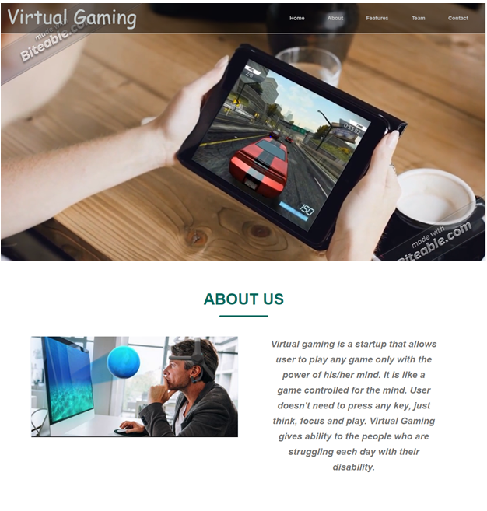

Figure 14:Home

### **Features**

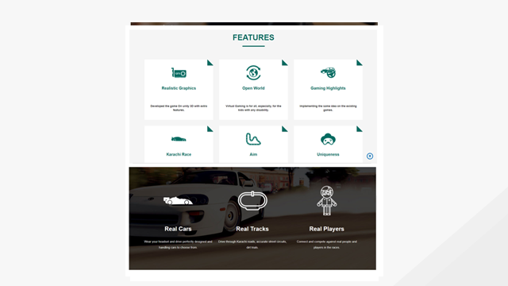

Figure 15:Features

## **Project Components & Team**

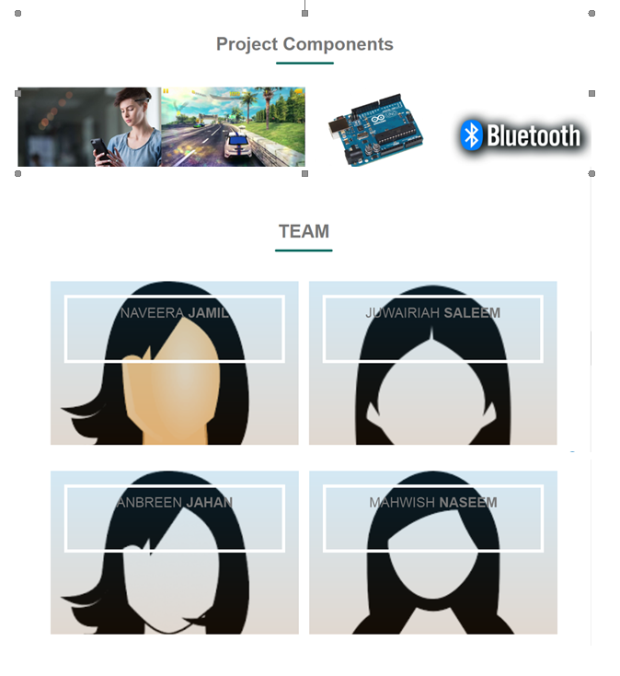

Figure 16:Project Components & team

## **Contact**



Figure 17:Contact

# **CONCLUSION**

In a nut shell, the proposed system i.e. Virtual Gaming provides means of entertainment to those who undergo painful time-taking treatments. It is like a brain exercise as it requires user’s excellent attention and focus to play the game. VG helps improve the mental focus of those who tend to lose focus easily in a fun and interesting way. It is not only for disabled people; instead it is accessible for all. We have implemented our idea on the car racing game we have developed and also on some of the existing games like Need for Speed etc. As the time progresses in the near future, more and more advanced Brain Computer Interface (BCI) devices having more sensors would be used to control the game through brain much more efficiently and accurately.A mesmerizing environment using VR equipment like a 3D mouse and a head-mounted display will be integrated to do a comparative study. Besides, during the learning experience, the attention and concentration levels of the user would be captured and analyzed for better understanding. The upcoming games could be designed and developed in such a way that they could be controlled by the brain and that the gaming environments and games know how to adjust according to the cognitive and motoric abilities of the gamer.

**APPENDIX A**

## **Glossary**

**EEG Headset**

Electroencephalography (**EEG**) is an electrophysiological monitoring method to record electrical activity of the brain. It is typically noninvasive, with the electrodes placed along the scalp, although invasive electrodes are sometimes used such as in electrocorticography.

**Arduino Uno**

The Arduino Uno is a microcontroller board based on the ATmega328 (datasheet). It has 14 digital input/output pins (of which 6 can be used as PWM outputs), 6 analog inputs, a 16 MHz ceramic resonator, a USB connection, a power jack, an ICSP header, and a reset button.

**Arduino Leonardo**

The Arduino Leonardo is a microcontroller board based on the ATmega32u4 (datasheet). It has 20 digital input/output pins (of which 7 can be used as PWM outputs and 12 as analog inputs), a 16 MHz crystal oscillator, a micro USB connection, a power jack, an ICSP header, and a reset button.

**Brainwaves**

At the root of all our thoughts, emotions and behaviours is the communication between neurons within our brains. Brainwaves are produced by synchronised electrical pulses from masses of neurons communicating with each other.

**Alpha waves**

Alpha waves are [neural oscillations](https://en.wikipedia.org/wiki/Neural_oscillations) in the frequency range of 7.5–12.5 [Hz](https://en.wikipedia.org/wiki/Hertz) arising from synchronous and coherent (in phase or constructive) electrical activity of [thalamic](https://en.wikipedia.org/wiki/Human_thalamus) pacemaker cells in humans.

**Beta waves**

Beta wave, or beta rhythm, is a [neural oscillation](https://en.wikipedia.org/wiki/Neural_oscillation) (brainwave) in the [brain](https://en.wikipedia.org/wiki/Human_brain) with a [frequency](https://en.wikipedia.org/wiki/Frequency) range of between 12.5 and 30 [Hz](https://en.wikipedia.org/wiki/Hertz) (12.5 to 30 [cycles per second](https://en.wikipedia.org/wiki/Cycles_per_second).

**Gamma waves**

A gamma wave is a pattern of neural oscillation in humans with a frequency between 25 and 100 Hz, though 40 Hz .

**Delta waves**

A delta wave is a high [amplitude](https://en.wikipedia.org/wiki/Amplitude) [brain wave](https://en.wikipedia.org/wiki/Neural_oscillation) with a frequency of oscillation between 0.5–4 [hertz](https://en.wikipedia.org/wiki/Hertz). Delta waves, like other brain waves, are recorded with an [electroencephalogram](https://en.wikipedia.org/wiki/Electroencephalography)[[1]](https://en.wikipedia.org/wiki/Delta_wave#cite_note-isbn0-550-14110-3-1) (EEG) and are usually associated with the deep stage 3 of [NREM](https://en.wikipedia.org/wiki/NREM) sleep, also known as [slow-wave sleep](https://en.wikipedia.org/wiki/Slow-wave_sleep) (SWS), and aid in characterizing the depth of sleep.

**Theta waves**

Theta waves generate the theta rhythm, a [neural oscillatory](https://en.wikipedia.org/wiki/Neural_oscillation) pattern that can be seen on an [electroencephalogram](https://en.wikipedia.org/wiki/Electroencephalography) (EEG), recorded either from inside the brain or from electrodes attached to the scalp.

**Bluetooth**

Bluetooth is defined as being a short-range radio technology (or wireless technology) aimed at simplifying communications among Internet devices and between devices and the Internet. It also aims to simplify data synchronization between Internet devices and other computers.

**TX**

In communication technology, tx means transmitter (or transmitting) It also used to stand for Telex, a now-obsolete form of communication where characters typed on a teletype would appear on a printer at a remote location.

**RX**

A receiver mostly refers to that part of a device that receives signals; often, the device acts as both a transmitter and a receiver(transceiver) such as in the case of cell phones (cellular radio) and antennas used for data communication.

**Unity 3d**

Unity3D is a powerful cross-platform 3D engine and a user friendly development environment. Unity should interest anybody who wants to easily create 3D games and applications for mobile, desktop, the web, and consoles.

**Serial Software**

The Arduino hardware has built-in support for serial communication on pins 0 and 1 (which also goes to the computer via the USB connection). The native serial support happens via a piece of hardware (built into the chip) called a [UART](http://en.wikipedia.org/wiki/UART). This hardware allows the at mega chip to receive serial communication even while working on other tasks, as long as there room in the 64 byte serial buffer.